**Yelp Data Exploration**

Tables:

Documentation of the tables can be found here: <https://www.yelp.com/dataset/documentation/main>

|  |  |
| --- | --- |
| **Table** | **Description** |
| business | Information about a business. Note: please ignore the is_open column as it is not accurate |
| category | The categories that a business falls into |
| user | Information about a user |
| review | Information about a review by a user |

# **1. business table**

An example ( business_id: _ab50qdWOk0DdB6XOrBitw )

<https://www.yelp.com/biz/_ab50qdWOk0DdB6XOrBitw>

-- Show the first 20 rows of table

SELECT *

SELECT *

FROM yelp.business

LIMIT 20;

-- Count the total number of rows (businesses) in the table

SELECT COUNT(*)

FROM yelp.business;

-- Count the total number of businesses in the "business" table (use distinct in case there are duplicate rows with the same businss_id)

SELECT COUNT(DISTINCT business_id)

FROM yelp.business;

-- The postal_code column seems to use the numeric data type, which is problematic (states on east coast will have postal_codes that look like 01234, but this will become 1234 in the data). Let’s change the data type to be CHAR (5), which is a 5-digit string. We then left filled the postal_code with 0 so that 1234 becomes 01234.

ALTER TABLE yelp.business

MODIFY postal_code CHAR(5);

UPDATE yelp.business

SET postal_code=LPAD(postal_code,5,'0');

-- Show the number of businesses in each state

SELECT state, COUNT(*)

FROM yelp.business

GROUP BY state;

-- Summary statistics for stars and review_count

SELECT 'Total',

COUNT(stars) as stars,

COUNT(review_count) as review_count

FROM yelp.business

UNION

SELECT 'Average',

AVG(stars),

AVG(review_count)

FROM yelp.business

UNION

SELECT 'Min',

MIN(stars),

MIN(review_count)

FROM yelp.business

UNION

SELECT 'Max',

MAX(stars),

MAX(review_count)

FROM yelp.business;

# **2. category table**

-- Show the first 20 rows of table

SELECT *

SELECT *

FROM yelp.category

LIMIT 20;

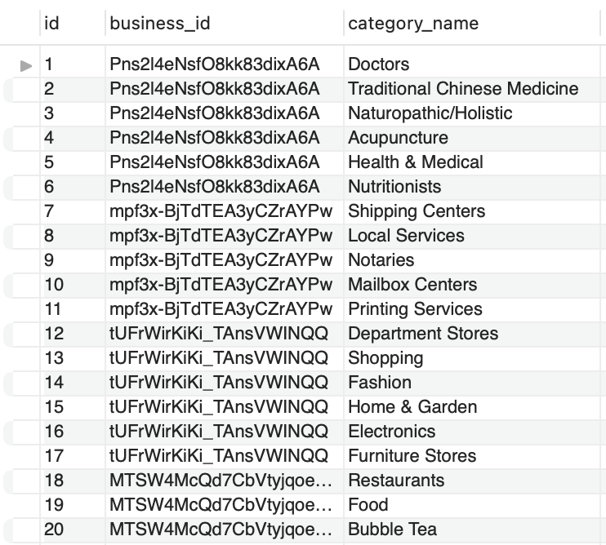

-- Show the number of unique categories

SELECT COUNT(DISTINCT category_name)

FROM yelp.category;

-- Order by category_name, show 20 unique categories

SELECT DISTINCT category_name

FROM yelp.category

ORDER BY category_name

LIMIT 20;

# **3. user table**

An example ( user_id: Hi10sGSZNxQH3NLyWSZ1oA)

<https://www.yelp.com/user_details?userid=Hi10sGSZNxQH3NLyWSZ1oA>

-- Show the first 20 rows of table

SELECT *

SELECT *

FROM yelp.user

LIMIT 20;

-- Summary statistics for review_count, average_stars, and fans

SELECT 'Total',

COUNT(review_count) as review_count,

COUNT(average_stars) as average_stars,

COUNT(fans) as fans

FROM yelp.user

UNION

SELECT 'Average',

AVG(review_count) as review_count,

AVG(average_stars) as average_stars,

AVG(fans) as fans

FROM yelp.user

UNION

SELECT 'Min',

MIN(review_count) as review_count,

MIN(average_stars) as average_stars,

MIN(fans) as fans

FROM yelp.user

UNION

SELECT 'Max',

MAX(review_count) as review_count,

MAX(average_stars) as average_stars,

MAX(fans) as fans

FROM yelp.user;

# **4. review table**

-- Show the first 20 rows of table

SELECT *

SELECT *

FROM yelp.review

LIMIT 20;

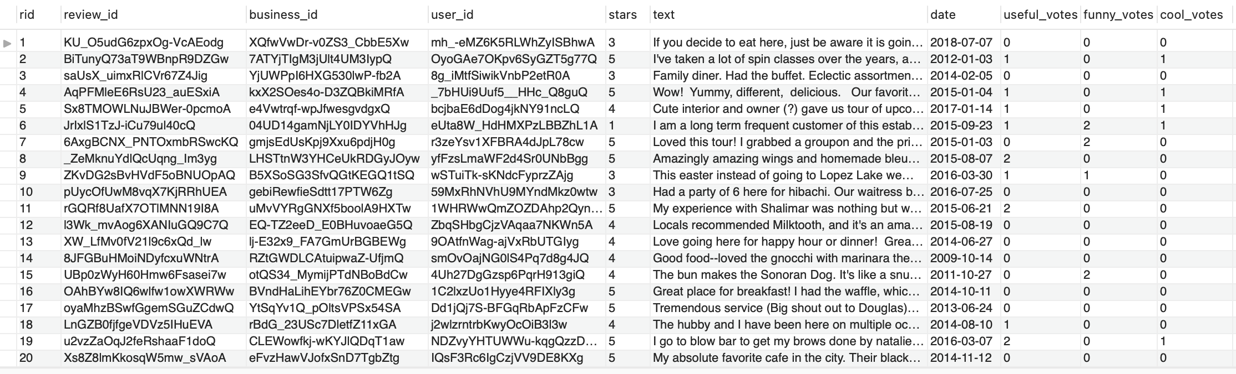

-- Show the dates for the earliest/latest reviews

SELECT MIN(date), MAX(date)

FROM yelp.review;

